**Assignment-based Subjective Questions**

1. From your analysis of the categorical variables from the dataset, what could you infer about their effect on the dependent variable?

**Ans**: The impact of categorical variables such as – season , weathersit,weekday,holiday are not

explain much variation in the dependent variable ‘CNT’.

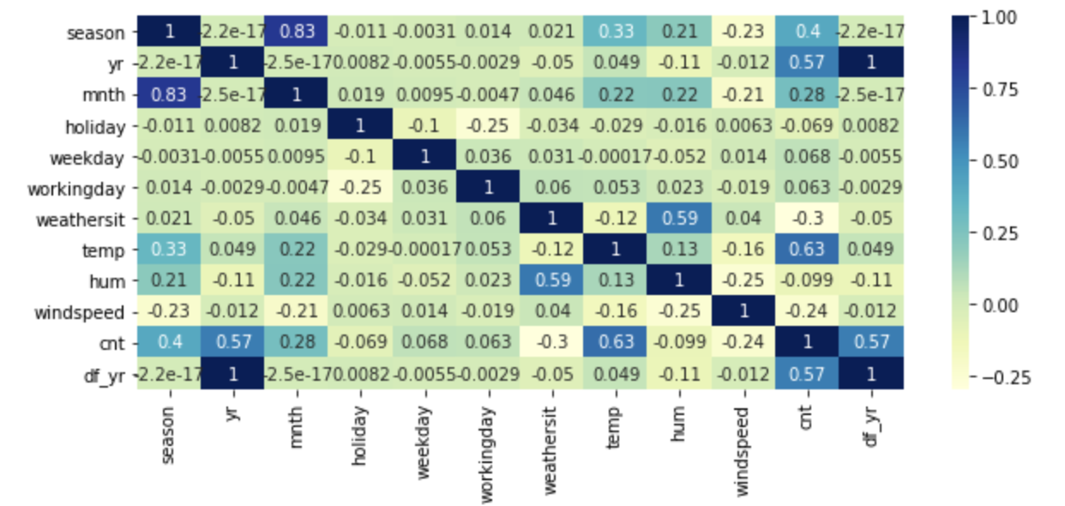

2. Why is it important to use **drop_first=True** during dummy variable creation? (2 mark)

**Ans**: The parameter drop_first=True is important to use, as it helps in reducing the extra column created during dummy variable creation. It reduces the correlations created among dummy variables. Also we only need k-1 columns for ‘k’ levels.

3. Looking at the pair-plot among the numerical variables, which one has the highest correlation with the target variable? (1 mark)

**Ans**: ‘Temp’ variable has the highest correlation with the target variable of 63%.

4. How did you validate the assumptions of Linear Regression after building the model on the training set? (3 marks)

**Ans**: Pair-wise scatterplots is used for validating the linearity assumption as it is easy to visualize a linear relationship on a plot. In addition and similarly, a partial residual plot that represents the relationship between a predictor and the dependent variable while taking into account all the other variables may help visualize the true nature of the relationship between variables.

We can use Q-Q plot to compare two probability distributions.

Multicollinearity tests can be checked using heatmaps between the variables.

5. Based on the final model, which are the top 3 features contributing significantly towards explaining the demand of the shared bikes? (2 marks)

**Ans**: 3 Features contributing significantly are: Weather Situation, Year and Season

Demands increases in the month of 3, 5, 6, 8 ,9, 7, 10 and year.

**General Subjective Questions**

1. Explain the linear regression algorithm in detail.

**Ans**: Linear regression is one of the very basic forms of machine learning where we train a model to predict the behaviour of your data based on some variables. In the case of linear regression as you can see the name suggests linear that means the two variables which are on the x-axis and y-axis should be linearly correlated.

In some cases, the value will be linearly upward that means whenever X is increasing Y is also increasing or vice versa that means they have a correlation or there will be a linear downward relationship.

Use Cases of Linear Regression:

1. Prediction of trends and Sales targets – To predict how industry is performing or how many sales targets industry may achieve in the future.
2. Price Prediction – Using regression to predict the change in price of stock or product.
3. Risk Management- Using regression to the analysis of Risk Management in the financial and insurance sector.

Below are some important assumptions of Linear Regression. These are some formal checks while building a Linear Regression model, which ensures to get the best possible result from the given dataset.

* **Linear relationship between the features and target:**  
  Linear regression assumes the linear relationship between the dependent and independent variables.
* **Small or no multicollinearity between the features:**  
  Multicollinearity means high-correlation between the independent variables. Due to multicollinearity, it may difficult to find the true relationship between the predictors and target variables. Or we can say, it is difficult to determine which predictor variable is affecting the target variable and which is not. So, the model assumes either little or no multicollinearity between the features or independent variables.
* **Homoscedasticity Assumption:**  
  Homoscedasticity is a situation when the error term is the same for all the values of independent variables. With homoscedasticity, there should be no clear pattern distribution of data in the scatter plot.
* **Normal distribution of error terms:**  
  Linear regression assumes that the error term should follow the normal distribution pattern. If error terms are not normally distributed, then confidence intervals will become either too wide or too narrow, which may cause difficulties in finding coefficients.  
  It can be checked using the **q-q plot**. If the plot shows a straight line without any deviation, which means the error is normally distributed.
* **No autocorrelations:**  
  The linear regression model assumes no autocorrelation in error terms. If there will be any correlation in the error term, then it will drastically reduce the accuracy of the model. Autocorrelation usually occurs if there is a dependency between residual errors.

2. Explain the Anscombe’s quartet in detail.

**Ans: Anscombe’s quartet** comprises four datasets that have nearly identical simple statistical properties, yet appear very different when graphed. Each dataset consists of eleven (x,y) points. They were constructed in 1973 by the statistician Francis Anscombe to demonstrate both the importance of graphing data before analysing it and the effect of outliers on statistical properties.

The quartet is still often used to illustrate the importance of looking at a set of data graphically before starting to analyse according to a particular type of relationship, and the inadequacy of basic statistic properties for describing realistic datasets.

This tells us about the importance of visualising the data before applying various algorithms out there to build models out of them which suggests that the data features must be plotted in order to see the distribution of the samples that can help you identify the various anomalies present in the data like outliers, diversity of the data, linear separability of the data, etc. Also, the Linear Regression can be only be considered a fit for the **data with linear relationships**and is incapable of handling any other kind of datasets.

3. What is Pearson’s R?

**Ans**: Pearson’s R or Pearson Correlation Coefficient is a measure of the strength of a linear association between two variables and is denoted by r. Basically, a Pearson product-moment correlation attempts to draw a line of best fit through the data of two variables, and the Pearson correlation coefficient, r, indicates how far away all these data points are to this line of best fit (i.e., how well the data points fit this new model/line of best fit).

The Pearson correlation coefficient, r, can take a range of values from +1 to -1. A value of 0 indicates that there is no association between the two variables. A value greater than 0 indicates a positive association; that is, as the value of one variable increases, so does the value of the other variable. A value less than 0 indicates a negative association; that is, as the value of one variable increases, the value of the other variable decreases.

The stronger the association of the two variables, the closer the Pearson correlation coefficient, r, will be to either +1 or -1 depending on whether the relationship is positive or negative, respectively. Achieving a value of +1 or -1 means that all your data points are included on the line of best fit – there are no data points that show any variation away from this line. Values for r between +1 and -1 (for example, r = 0.8 or -0.4) indicate that there is variation around the line of best fit. The closer the value of r to 0 the greater the variation around the line of best fit.

4. What is scaling? Why is scaling performed? What is the difference between normalized scaling and standardized scaling?

**Ans**: Scaling in machine learning is one of the most critical steps during the pre-processing of data before creating a machine learning model. Scaling can make a difference between a weak machine learning model and a better one. The most common techniques of feature scaling are Normalization and Standardization. Normalization is used when we want to bound our values between two numbers, typically, between [0,1] or [-1,1]. While Standardization transforms the data to have zero mean and a variance of 1, they make our data unitless. Refer to the below diagram, which shows how data looks after scaling in the X-Y plane.

Also, another reason why feature scaling is applied is that few algorithms like Neural network gradient descent converge much faster with feature scaling than without it.

Feature scaling is essential for machine learning algorithms that calculate distances between data. The ML algorithm is sensitive to the “relative scales of features,” which usually happens when it uses the numeric values of the features rather than say their rank. Since the range of values of raw data varies widely, in some machine learning algorithms, objective functions do not work correctly without normalization. For example, the majority of classifiers calculate the distance between two points by the distance. If one of the features has a broad range of values, the distance governs this particular feature. Therefore, the range of all features should be normalized so that each feature contributes approximately proportionately to the final distance.

Normalization is a scaling technique in which values are shifted and rescaled so that they end up ranging between 0 and 1. It is also known as Min-Max scaling.

Standardization is another scaling technique where the values are centered around the mean with a unit standard deviation. This means that the mean of the attribute becomes zero and the resultant distribution has a unit standard deviation.

5. You might have observed that sometimes the value of VIF is infinite. Why does this happen?

**Ans**: VIF is an index that provides a measure of how much the variance of an estimated regression coefficient increases due to collinearity.

If there is perfect correlation, then VIF = infinity. A large value of VIF indicates that there is a correlation between the variables.

To solve this problem we need to drop one of the variables from the dataset which is causing this perfect multicollinearity.

6. What is a Q-Q plot? Explain the use and importance of a Q-Q plot in linear regression.

**Ans**: The Q-Q plot, is a graphical tool to help us assess if a set of data plausibly came from some theoretical distribution such as a Normal or exponential. A Q-Q plot is a scatterplot created by plotting two sets of quantiles against one another. If both sets of quantiles came from the same distribution, we should see the points forming a line that’s roughly straight. Q-Q plots take your sample data, sort it in ascending order, and then plot them versus quantiles calculated from a theoretical distribution. The number of quantiles is selected to match the size of your sample data. While Normal Q-Q Plots are the ones most often used in practice due to so many statistical methods assuming normality, Q-Q Plots can actually be created for any distribution. Also, it helps to determine if two data sets come from populations with a common distribution.

**Importance in linear regression:**

a) It can be used with sample sizes also

b) Many distributional aspects like shifts in location, shifts in scale, changes in symmetry, and the presence of outliers can all be detected from this plot.

It is used to check following scenarios:

If two data sets —

* come from populations with a common distribution
* have common location and scale
* have similar distributional shape
* have similar tail behaviour